Assignment 3
SSE
Olha Bila and Liliia Naumeiko

Steps to improve our project
Add functionalities to project 2
Eliminate vulnerabilities 2
Avoid SQL injection using parameterized queries. 2
Enforce selection of a strong password. 3
Implement session timeout and encrypt session ID. 4
Broken Authentication 4
Store passwords encrypted using slow salted hashing 5
Encrypt communication end to end (i.e. enforce the use of HTTPS) 6
Ensure that each student can only access his/her own personal information and not the information of other students 9
Ensure that the following operations are logged: user logins, payment of fees, modification of the information about a module 9
Implement blacklists to block IP addresses that perform subsequent failed logins (e.g., 3 failed logins) 10
Conclusion 11

Add functionalities to project

Firstly, we have decided to eliminate problems which were found via working deeper with our project.
1. Problems with script: We have paid more attention to our data base script. Now before running our project just run sql script from github and change settings in application.properties file. There is an excel file which consist of plain password and encrypted password.
2. We added a function to write modules to enroll to via id and the associated "submit".\
3. Visualisation was implemented, but wait a second to see it as vega-lite is not as quick as light.
4. My Modules displays now only modules of current user without any problems.
5. 'Pay' button does have an impact on the backend: it change the permition to choose modules.
6.We connected HTTPSession to use logout.

Eliminate vulnerabilities
After re-building our project it was required to check for vulnerabilities presence and eliminate them.

Avoid SQL injection using parameterized queries.
In this web application a technique with bind parameters is being used. It is the reason there are no SQL Injection.
Bind parameters act as placeholders in your query for which you can set values before the query gets executes. They are regularly used in the WHERE clause of a query. You should always prefer them over inlining a parameter value because bind parameters can prevent SQL injection vulnerabilities. A positional bind parameter gets referenced by its position. In the query, positional bind parameters consist of a `?` followed by a number that specifies the position. Spring Data JPA then provides the required code to set the bind parameter values. It sets the value of each method parameter as the value of a bind parameter with the same position. So, the value of the first method parameter gets set as the value of the bind parameter at position 1.
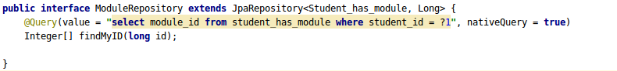
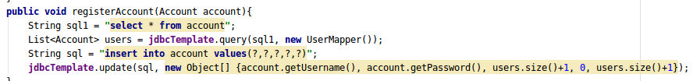

Enforce selection of a strong password.

The security of the authentication mechanism is directly related to the password strengths. If the attacker is aware of the user name, a weak password can be easily guessed by the attackers using automatic functions. Thereby giving the attacker unauthorised access to the user account and exposing the sensitive information.
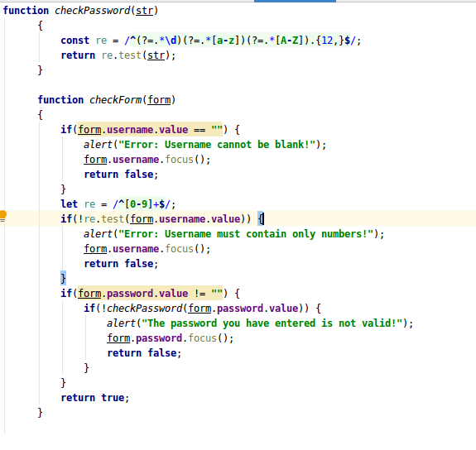
It is one of the vital requirements for protecting against Broken Authentication, as it does not allow to create account with default, weak, or well-known passwords, such as “Password1” or “admin/admin“.
The function chechPassword was created to provide checking of password.

Implement session timeout and encrypt session ID.

Session timeout in seconds.server.session.timeout in the application.properties file is now deprecated. The correct setting is: server.servlet.session.timeout= 60
Typically, to protect against session fixation, we want to just create a new session and invalidate the old one as well. But a higher level of security involves a tossing the old session and making a new session for each and every request.
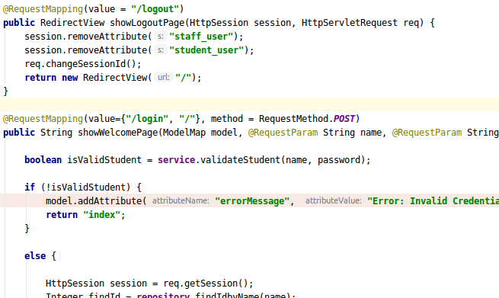

HTTPonly renders the saved cookie in the browser, making it inaccessible to third party scripts that attempt to access the cookies. It is as a lock on that cookie jar that blocks XSS scripts from collecting cookies and sending this data back to malicious hosts.
server.servlet.session.cookie.http-only=true

Broken Authentication

How can we secure this session from getting hijacked? We have decided to store the session ID in the cookie rather than on the URL. It was added to the application.properties file:
server.session.tracking-modes=cookie
These actions also help to prevent the application from Broken Authentication by using a server-side, secure, built-in session manager that generates a new session ID with after login. Session IDs should not be in the URL, be securely stored and invalidated after logout, idle, and absolute timeouts as stated before.

Store passwords encrypted using slow salted hashing

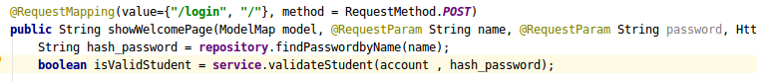
Bcrypt uses adaptive hash algorithm to store password. BCrypt internally generates a random salt while encoding passwords and hence it is obvious to get different encoded results for the same string. But one common thing is that everytime it generates a String of length 60.

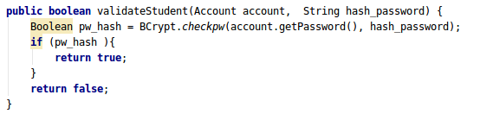
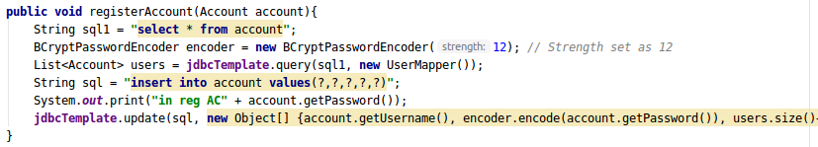

The hashes from the same password are different because of salting. So it is required to change data base and use different way of validation user rather than comperation..
Storing passwords using strong adaptive and salted hashing functions with a work factor (delay factor), such as Argon2, scrypt, bcrypt or PBKDF2 (in our case Bcrypt) will decrease the security risk.
1.username:
436634635
2.password:
sdvsd324324DGSDV
3.Different hashes for the same password because of salting
$2a$12$4r4FJsAx2KOM.v5qDVzDB.9k9ArJRbyTHicqR.9dO4RR68npe2rFS
$2y$12$E6kqHBLhfHh7CuMkrNk26ujRw6OFH4cdJdzU8vouPOY6XZOVXaf6K

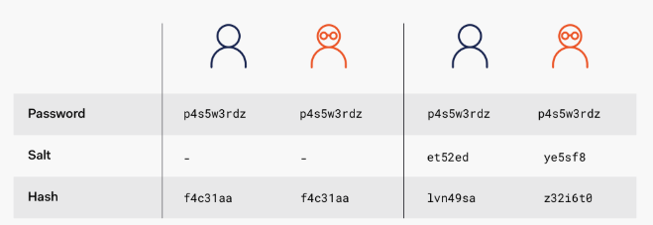
When the salt is unique for each hash, we inconvenience the attacker by now having to compute a rainbow table for each user hash. This creates a big bottleneck for the attacker. Ideally, we want the salt to be truly random and unpredictable to bring the attacker to a halt.
While the attacker may be able to crack one password, cracking all passwords will be unfeasible.

Encrypt communication end to end (i.e. enforce the use of HTTPS)
In our app we used generated a self-signed SSL certificate and redirected HTTP to HTTPS to create end-to-end decryption to prevent our app from man-in-the-middle.
Scenario (for Sensitive Data Exposure) - Transmission over an unsecured channel:
-Transmitting data in clear text without HTTPS is a big risk.
-Use valid SSL certificate and keep certificate active.
-Some web pages are not over HTTPS and intruders may get access to the website from these unsecured pages.
Prevention: Using HTTPS for communication.
To enable HTTPS, we'll provide a Spring Boot application with this keystore containing the SSL certificate.
PKCS12, an industry-standard format. Oracle recommends to adopt the PKCS12 format.
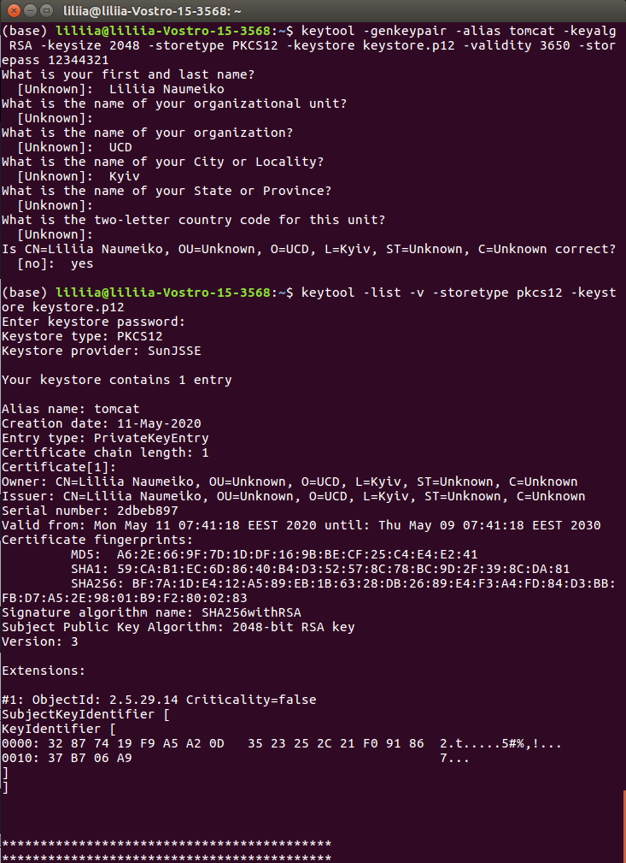

The first thing to do is placing the keystore file inside the Spring Boot project. We want to put it in the resources folder or the root folder.
Made a browser trust an SSL certificate.
When using a keystore in the industry-standard PKCS12 format, we should be able to use it directly without extracting the certificate.
In Chrome, we can write the following URL in the search bar: chrome://flags/#allow-insecure-localhost and activate the option.
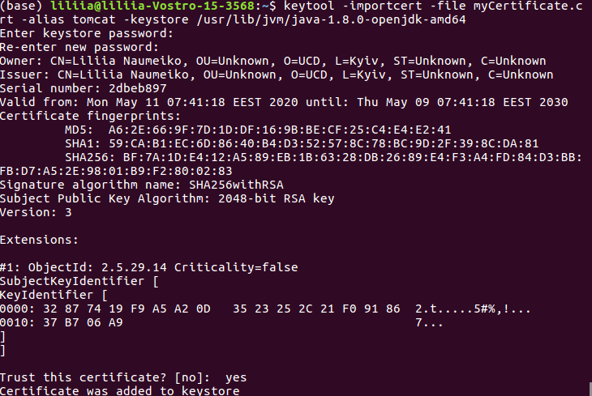
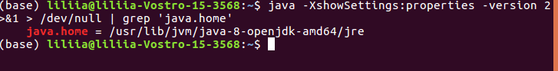

With Https there was a problem with sending POST requests because of the csrf-protection. It affects only the non-GET requests, and it's turned on by default on Spring Boot 2.
http.csrf().disable();

Ensure that each student can only access his/her own personal information and not the information of other students
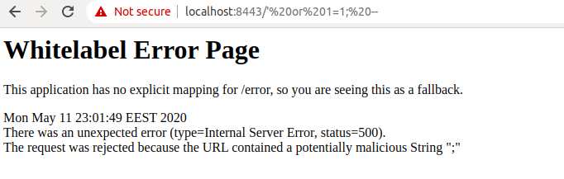
Go back arrow only shows statistics and all modules for unenrolled students. It is caused by creating a new HTTP Session.
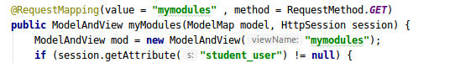

Ensure that the following operations are logged: user logins, payment of fees, modification of the information about a module

Username as a password is unique for each user, so it was required to eliminate the same username existance.
Log file is irreplaceble in each server, because it works like an evidence of wrong exploiting of the web app. The Spring Boot has logging enabled automatically, but if we need it more detailed we can work with slf4j library.
import org.slf4j.Logger;
import org.slf4j.LoggerFactory;

private static final Logger logger = LogManager.getLogger(SseApplication.class);

2020-05-14 17:35:43,161 INFO c.u.S.c.LoginController [https-jsse-nio-8443-exec-5] This user logged in succesfully: 19602505
2020-05-14 17:35:57,023 INFO c.u.S.c.LoginController [https-jsse-nio-8443-exec-3] This user paid for courses succesfully: 19602505
2020-05-14 17:36:03,382 INFO c.u.S.c.LoginController [https-jsse-nio-8443-exec-2] The user 19602505 enrolled succesfully to course with id 12

Implement blacklists to block IP addresses that perform subsequent failed logins (e.g., 3 failed logins)
IP blacklist is a great solution from brute force attack. It will block a client IP address with 3 wrong attempts.
2020-05-14 17:41:47,567 WARN c.u.S.c.LoginController [https-jsse-nio-8443-exec-10] This user is blocked, because of 3 times wrong login. 127.0.1.1
2020-05-14 17:41:47,568 WARN c.u.S.c.LoginController [https-jsse-nio-8443-exec-10] Show the list of IP adresses {127.0.1.5=3, 127.0.1.8=3, 127.0.1.1=3}
Of course the easiest way to implent IP blacklist is to use integreted to Spring Boot Security tools( such as org.apache.catalina.filters and CacheLoader, but as this part of assignment worth A+ we`ve decided to write our own function which will add suspicious IP addresses to blacklist. In real life it is better to use CacheLoader to enable functionality of IP recconnection after some period of time. But as it is studying project we’ve decided that it is possible just to create full deny. This black list is cleared after you stop running the SSE project. But if it is wished to use it everytime it is needed just to write down it to file.
private String getClientIP() {
String xfHeader = request.getHeader("X-Forwarded-For");
if (xfHeader == null){
return request.getRemoteAddr();//to obtain the client's IP address
}
return xfHeader.split(",")[0];
}
String remote_ip = InetAddress.getLocalHost().getHostAddress();// is to obtain the client's host name
This ip of user 0:0:0:0:0:0:0:1and host address of user 127.0.1.1
As the project is run on the localhost the only IP address we can see is ::1/128 (0:0:0:0:0:0:0:1).
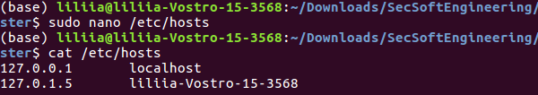

Well, it is small info about Ubuntu hostname mapping. The loopback (127.0.0.1) is a virtual network interface that a computer uses to communicate with itself and to connect to servers on the local machine. But in our app we will work with 127.0.1.1 IP address which is ip of computer hostname. We used it to show in details how IP blocking works.
But, In real network it is needed to use getRemoteAddr() to have client’s IP.
The Remote Address Filter allows us to compare the IP address of the client that submitted this request against one or more regular expressions, and either allow the request to continue or refuse to process the request from this client.

Conclusion
As the students who were supposedly meant to correct our application experienced difficulties in running it, we did not have a detailed explanation about vulnerability presence in our project. But we followed lecturers instructions and our own ideas to make a project as good as possible due to current situation.
During our joint work on this project we improved our knowledges in programming, logics and softskills.
But the main idea is that we have read a lot of up-to-date information about Spring Boot Security, about web security, about OWASP vulnreabilities and problems which others stacked during implementing of secutiry funtions.
We obtained knowldges how vulnerabilities are dangereous for clients and developers, and how it is possible to implement security functions which will protect users` data frsom malisious people.

